Name: Quang Huynh

CRQ

Document 1:

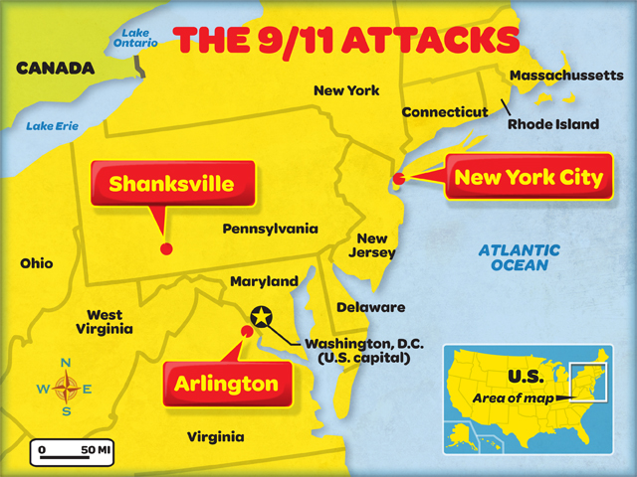

**Geographic Context** – where this historical development is taking place, and why it is taking place there.

Using document 1, explain the geographic context of the historical developments shown on the map.

In the map above, the terrorist group al-Qaeda had hijacked planes to fly into buildings into the Twin Towers in New York City on September 11th. 2011. These series of attacks was one of the most deadliest terrorist attacks in the United States.

Document 2:

**September 11, 2001**: Attacks on the World Trade Centre's twin towers and the Pentagon in the US. Washington blames bin Laden and al-Qaeda for the attacks.

**September 16, 2001**: General Pervez Musharraf, Pakistan's president, pledges support for US efforts to arrest bin Laden and appeals to his nation for support. Taliban supporters mount demonstrations.

**September 20, 2001** - George Bush, the then US president, calls on the Taliban to hand over bin Laden and all other al-Qaeda leaders, close its terrorist training camps, or face the consequences.

**September 21, 2001** - Abdul Salaam Zaeef, the Taliban's ambassador to Pakistan, says that bin Laden would not be given up without evidence linking him to the 9/11 attacks.

**September 22, 2001** - Fighting begins between the Northern Alliance and the Taliban.

**September 24, 2001**: The Taliban calls for a jihad against the US if its forces enter Afghanistan.

**October 6, 2001** - Bush warns the Taliban that "time was running out" unless they gave up "terrorist" suspects.

**October 7, 2001**: US and British forces begin intense bombing of the Taliban's air defence installations and airport-based command centres.

*Source: Timeline - Taliban in Afghanistan www.aljazeera.com*

Identify and explain the purpose of the document.

The purpose of this document was to show that the United States was taking action after 9/11. They were trying to do justice and punish the people behind these attacks. Then, a battle would begin as a result. Conflicts would arise and fighting occurred. This document is showing the timeline of the events that happened, so if another event like this ever happens again, we would know the right steps to take.

**Document 1 Document 2**



**September 11, 2001**: Attacks on the World Trade Centre's twin towers and the Pentagon in the US. Washington blames bin Laden and al-Qaeda for the attacks.

**September 16, 2001**: General Pervez Musharraf, Pakistan's president, pledges support for US efforts to arrest bin Laden and appeals to his nation for support. Taliban supporters mount demonstrations.

**September 20, 2001** - George Bush, the then US president, calls on the Taliban to hand over bin Laden and all other al-Qaeda leaders, close its terrorist training camps, or face the consequences.

**September 21, 2001** - Abdul Salaam Zaeef, the Taliban's ambassador to Pakistan, says that bin Laden would not be given up without evidence linking him to the 9/11 attacks.

**September 22, 2001** - Fighting begins between the Northern Alliance and the Taliban.

**September 24, 2001**: The Taliban calls for a jihad against the US if its forces enter Afghanistan.

**October 6, 2001** - Bush warns the Taliban that "time was running out" unless they gave up "terrorist" suspects.

**October 7, 2001**: US and British forces begin intense bombing of the Taliban's air defence installations and airport-based command centres.

*Source: Timeline - Taliban in Afghanistan www.aljazeera.com*

**Causation** – is a cause an effect relationship between events and ideas

Identify ***and*** explain a ***cause-and-effect*** relationship associated with the events, ideas, or historical developments in documents 1 and 2. Be sure to use evidence from ***both*** documents 1 and 2 in your response.

In document 1, the maps show attacks made on September 11th, 2001. These attacks would lead to the United States to take measures, as shown in document two. After the 9/11 attacks, the United States would find the group responsible for doing the attacks and punish them. So, the attacks on 9/11 led to movements made by the United States to do justice by trying to arrest the leader of al-Qaeda.